EOG Feature extraction summary -

1. Preprocessing:
   1. ICA (Independent Component Analysis) is carried out on the EEG signal to extract the different artifacts including EOG, ECG, and EMG. ICA application on extracted EOG is optional since the EOG signal is only adulterated by facial EMG signal.
   2. Baseline drift removal using wavelet transform does not affect the extraction of the features using the EOG [5].
2. SEM feature extraction [3]: ~~(~~**~~TODO: Add reference~~**~~)~~
   1. Wavelet decomposition is performed 10-level DWT of Daubechies order 4 (db4) wavelet. This process divides the signal into components of 10 scales where the scale k contains 125/2k+1 Hz to 125/2k Hz.
   2. The output waves are categorized as SEMs if they follow the below criteria:
      * slow sinusoidal excursion (0.2–0.6 Hz) lasting more than a second.
      * amplitude between 20 and 200 μV.

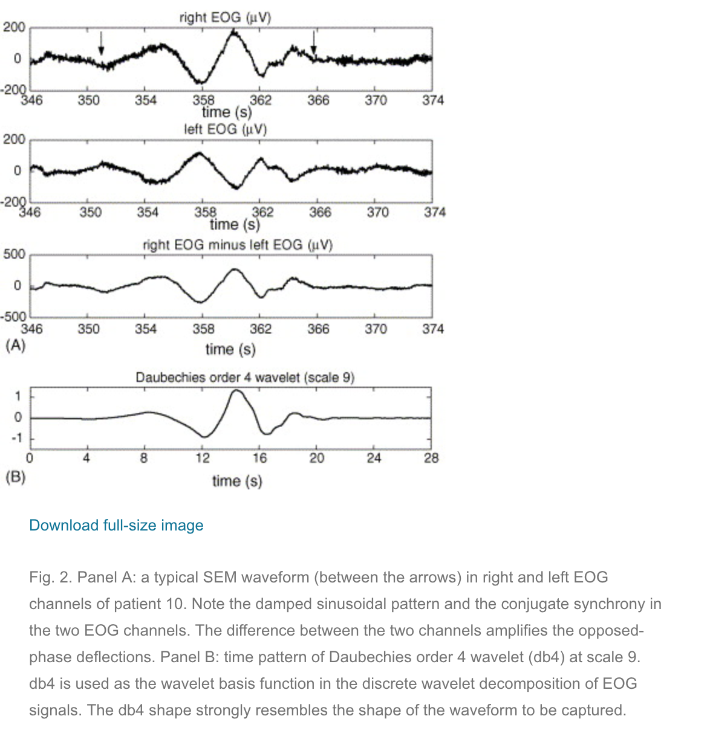

* The 10 levels decomposition is necessary to extract the frequency range of slow eye movements (**typically 0.2–0.6 Hz**). Since the EOG was sampled at 128 Hz (band limited to 64 Hz), the first detail (scale 1) principally encompasses frequencies in the range 32–64 Hz (central frequency 48 Hz). The subsequent details (higher scales) are centered at half the frequency of the previous detail. Therefore, details below scale 7 are necessary to capture the band 0.2–0.6 Hz.

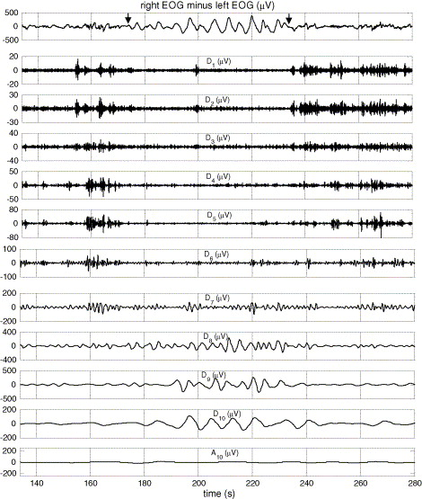

Fig. 3. A portion of the recording of patient 2 containing an SEM episode according to clinicians (from *t* = 174 to 234 s), and its wavelet decomposition into 10 levels of details (*D*1 − *D*10) and one approximation *A*10. The decomposed signal is the difference between right and left EOG. The arrows in the top panel denote the start and end of the SEM interval. Frequency components captured by details move from high-frequencies towards low frequencies as scale increases from 1 to 10 (32–64 Hz at scale 1 vs. 0.0625–0.125 at scale 10). Approximation contains the residual lower frequency information. The SEM event is mostly visible in details 8–10.

* The energy values at each of the 10 scales of the output wave are calculated using the formula.  
  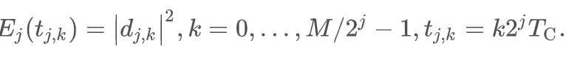
* SEM energy proportion is computed using the below formula using the energy at each of the 10 scales. We will be considering the energy of the low-frequency scale i.e 7 to 10.  
  

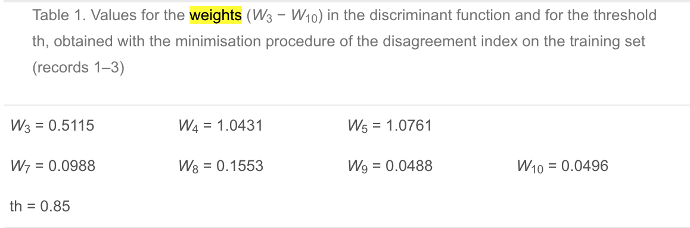

The weight values are a standard for SEM detection using DWT [1]. The other papers have also referenced this work and used the same set of weights to compute the Energy ratio.

So based on the above computation, the features of SEM are detected. The list of features are:

1. The SEM energy proportion.
2. The mean Amplitude of the SEM signal waves. (The lower frequency waves of 0.2 - 0.6 Hz, i.e the scale 7 to 10).
3. The variance in the Amplitude of the SEM signal waves.

2. Saccade feature extraction: (**~~TODO: Figure out Peak Velocity~~ - [6] derivative of the EOG signal will provide us the velocity measures w.r.t time**)

Saccades are similar to REM (Rapid Eye Movement) in their waveform. The key difference between the two waveforms is that REM is a kind of movement during sleeping stages and saccade is during wakefulness.

* Pass the horizontal EOG signal through a filter of 1 Hz to 8Hz.
* Take the first derivative of the resultant signal to produce a waveform of speed with respect to time.
* Compute the velocity threshold to be considered as Saccadic movement. This threshold is set to 5.0 [5] but can be adjusted based on the scale of the data.
* All the continuous points which are above the threshold form the points of the same saccade.
* After figuring out the region of the saccade compute the features based on the Amplitude of the original signal.
  + Mean Amplitude
  + Variance in Amplitude
  + Saccadic Peak Velocity (Max amplitude of the differentiated waveform [6]).
  + The ratio of the Saccadic Peak velocity to the max amplitude.
  + Duration of Saccade - optional [Not mentioned in the literature.]

3. Eyeblink features:

* Process the vertical EOG by 10 Hz low pass filter. The blink frequency is very low.
* Calculate the first order derivative of the signal to provide a wave with the velocity/speed measure over time.
* Apply the Vcl and Vo thresholds on the differentiated signal. A blink is characterized by 4 consecutive points 2 points equal the Vcl and the other 2 equal the Vo.
* Then verify the categorization of the blink, by applying time constraint of < 0.5s and amplitude threshold of >100 [5].
  + The values of Vcl and Vo are based on empirical evidence in the paper [5][7]. The values were set to 10 and -10 respectively.

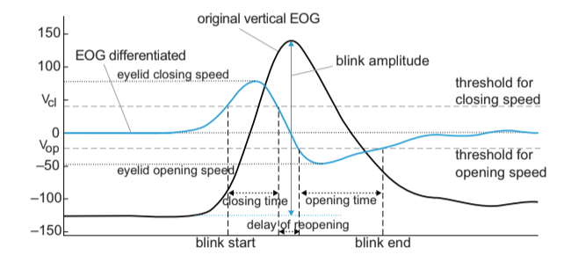

4. Power Spectral Density ratios:

* The power spectral density ratios of Low frequency to high frequency contains the transitional information from the vigilance state on both the horizontal and vertical signals[5].
  + Apply the Fast Fourier Transform to calculate the energy within the selected time window.
  + LF - 0 - 1 Hz and HF - 1 - 20 Hz.
  + Features:

Feature Definition:

1. SEM proportion: Indicates the fatigue level of the person [5].
2. SEM Mean Amplitude: This measure indicates the overall measure of the SEM voltage/power indicating the inclination to the first stage of sleep.
3. SEM Amplitude Variance: This measure indicates the spread of the SEM signal voltage/power in the selected time slot. The SEM Amplitude slowly increases while entering the first stage of the sleep. [5]
4. Saccadic peak velocity: Indicates how active a person is. An active person usually as a high Saccadic peak velocity.
5. Saccade Amplitude Variance: The variance of the Saccade power/voltage indicates the amount of variation or randomness from the mean. The higher the randomness or variation the higher is the alertness of the individual. The variance standardizes upon entering the early stages of sleep.
6. Blink duration: Blink duration or PERCLOS is a direct indicator of fatigue [5]. The higher the value the lower is the alertness of an individual.
7. Eye closing time & Eye opening time: This information is directly proportional to the closing and opening velocity of the blinks. During the early stages of sleep/drowsiness, the eye closing time is lower than the eye-opening time in co-relation with the opening and closing velocity.
8. Delay of reopening: Delay of reopening, defined as the time after full closure to the start of reopening the upper eyelid. In awake subjects, this delay lasts only a few ms but is increased under fatigue and reaches values of several hundred ms during a microsleep. [8]
9. Blink Interval: Indicates the gap between the blinks. This feature is very sensitive to changes in fatigue levels of the individual. [8]
10. Mean Amplitude (Blink/Saccade): This measure indicates the overall amplitude/power of the blink/saccade event for the time duration. The value directly corresponds to the opening and closing velocity of the blinks or saccadic velocity. A higher value indicates a higher state of alertness.
11. Closing Peak velocity & Opening Peak velocity: When the subject fatigues, blink velocity drops obviously. This rule applies to both the closing phase and opening phase, but the eyelid velocity of the closing phase is a more reliable feature than that of the opening phase.
12. Closing Mean velocity & Opening Peak velocity: The mean measures help to encompass the entire information regarding the velocity of the time slot and compare between the opening the closing phases of the blink. In the early stages of sleep, the mean closing velocity is higher than the mean opening velocity.
13. HEO LF energy: The power spectral density ratios from the low frequency to the high-frequency capture the transition from vigilance state to the drowsy state. [5]
14. VEO LF energy: The power spectral density ratios from the low frequency to the high-frequency capture the transition from vigilance state to the drowsy state. [5]

References

# Magosso, Elisa, et al. "A wavelet-based method for automatic detection of slow eye movements: A pilot study." *Medical engineering & physics* 28.9 (2006): 860-875.

1. Magosso, Elisa, et al. "Wavelet analysis of electroencephalographic and electro-oculographic changes during the sleep onset period." *2007 29th Annual International Conference of the IEEE Engineering in Medicine and Biology Society*. IEEE, 2007.
2. <https://drive.google.com/open?id=1pL-uNkJEmcplvGNxSx-KiSzpVd0yampD>
3. <https://www.researchgate.net/publication/257333869_Using_retina_modelling_to_characterize_blinking_Comparison_between_EOG_and_video_analysis>
4. <https://drive.google.com/file/d/1pL-uNkJEmcplvGNxSx-KiSzpVd0yampD/view>
5. <https://perceptual.mpi-inf.mpg.de/files/2013/03/vidal11_petmei.pdf>
6. <https://link.springer.com/content/pdf/10.1007%2Fs11818-008-0351-y.pdf>
7. <https://drive.google.com/file/d/1LjIxIsDDHHzrmdRHQ4UEQ8iE3mkkSbdU/view>